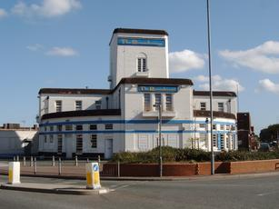



GOODMAYES LODGE

I moved into this home on September 29th 2008. The flat has a utility cupboard where things are stored. The hooks on the door are for storing trousers, jackets and coats. Then there are the shelves for putting anything on and a space underneath for vacuum cleaner, shopping trolley, buggies, plus a space for broom ironing board, the lot.

The large wardrobe has a strong box up on the top shelf to store money and other valuable stuff like jewellery. The other shelves are for clothes such as underwear and socks. In the hallway are hooks on the wall for coats and trousers. By the bathroom is a red button for calling the staff for assistance and a red cord for emergencies and lifeline. Every room has a red cord in case of danger.

The kitchen has an electric cooker and cupboards, plus a fridge.

Downstairs is the community lounge and community dining room, plus the office which is used for governing the support home.

Round the corner is the laundry room. It has three washing machines, plus dry cleaning machines.